16. ReactJS-HOL

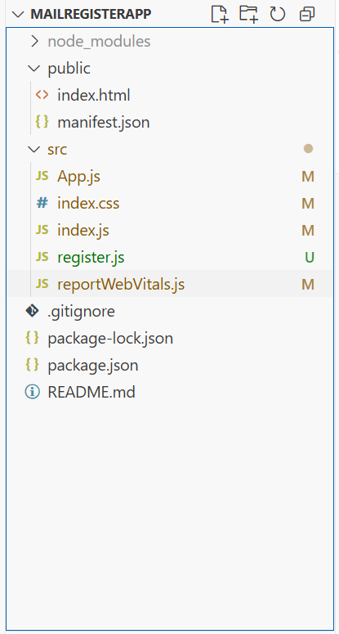

Register.js
import React, { Component } from 'react';
class Register extends Component {
constructor(props) {
super(props);
this.state = {
fullName: '',
email: '',
password: '',
errors: {
fullName: '',
email: '',
password: ''
}
};
}

handleChange = (event) => {
const { name, value } = event.target;
let errors = this.state.errors;

switch (name) {
case 'fullName':
errors.fullName =
value.length < 5 ? 'Full Name must be 5 characters long!' : '';
break;
case 'email':
const validEmailRegex = RegExp(
/^[^\s@]+@[^\s@]+\.[^\s@]+$/
);
errors.email = validEmailRegex.test(value)
? ''
: 'Email is not valid!';
break;
case 'password':
errors.password =
value.length < 8 ? 'Password must be 8 characters long!' : '';
break;
default:
break;
}
this.setState({ errors, [name]: value });
};
validateForm = (errors) => {
let valid = true;
Object.values(errors).forEach(
(val) => val.length > 0 && (valid = false)
);
return valid;
};

handleSubmit = (event) => {
event.preventDefault();
if (this.validateForm(this.state.errors)) {
alert('Valid Form');
} else {
if (this.state.errors.fullName) alert(this.state.errors.fullName);
if (this.state.errors.email) alert(this.state.errors.email);
if (this.state.errors.password) alert(this.state.errors.password);
}
};
render() {
return (
<div style={{ textAlign: 'center', marginTop: '50px' }}>
<h2 style={{ color: 'red' }}>Register Here!!!</h2>
<form onSubmit={this.handleSubmit}>
<div>
<label>Name: </label>
<input
type="text"
name="fullName"
onChange={this.handleChange}
required
/>
</div>
<br />
<div>
<label>Email: </label>
<input
type="email"
name="email"
onChange={this.handleChange}
required
/>
</div>
<br />
<div>
<label>Password: </label>
<input
type="password"
name="password"
onChange={this.handleChange}
required
/>
</div>
<br />
<button type="submit">Submit</button>
</form>
</div>
);
}
}

export default Register;

App.js
import React from 'react';
import Register from './register';
function App() {
return (
<div className="App">
<Register />
</div>
);
}
export default App;

index.js
import React from 'react';
import './index.css';
import App from './App';
import reportWebVitals from './reportWebVitals';
const root = ReactDOM.createRoot(document.getElementById('root'));
root.render(
<React.StrictMode>
<App />
</React.StrictMode>
);
reportWebVitals();
